Assignment 2 – CM 3210

Push Down Automata

094021d
M.D.S Duminda (B9)

Faculty Of Information Technology
University Of Moratuwa

Table Of Content

Contents
1.0 Chapter 1 An example for real world problem…………………………………………………………. 3
1.0 Introduction 3
1.1 Background and motivation 3
1.2 Problem 4
1.3 Proposed Solution 4
1.4 Summery 4
2.0 Chapter 2 What is push down Automata?......................................................................5
2.0 Introduction 5
2.1 Solve problem using push down Automata 5
Example 2.1.0 5
3.0 Chapter 3 Design…………………………………………………………………………………………………………. 7
3.1 Solve the problem using pushdown automata 7
3.1.1 Solution NPDA( pushdown Automata design ) 8
Example 3.1.1.1 9
Example 3.1.1.2 Rejected weightlifter 11
4.0 Chapter 4 Discussion ……………………………………………………………………………………………….13
4.1 How did I learn to create push down automata……………………………………………………….…….13
4.2 Other way of representing push down automata………………………………………….………………..13
Appendix
4.3 Reference ………………………………………………………………………………………………………………..………………15

Chapter 1
An Example for a Real world Problem

Introduction

In sport field there are many sports having competition in whole world. Every sports have many competitors. Today sports had come to new era of the world. Technology is a one of reason to update sports in the world. Earlier everything was done by human power. But today technology assists to do more task which did by human. In a tournament we might have several problem to solve. People always think to reduce their work and do work with very efficient way.
Among of those sports here describe about weightlifting game[3]. Weightlifting is an indoor sport. two lifts - the snatch and the clean and jerk. In the snatch [1] the bar is pulled overhead in one movement and In clean and jerk [2], the lifter can split or squat under the bar, when catching it on the shoulders - the lifter then stands erect. After standing erect the lifter dips (by flexion at the knee) then drives (jerks) the bar overhead using hip and knee extension and either splits or squats under the bar as it is caught overhead on extended arms.

Background and motivation

As Im a national level weightlifter I used to do sports well. Sports authorities use many ways to show performance of the lifters at a tournament. In world wide many sophisticated Technology use in a tournament. But in srilanka Most of task are done by people. But its better if there is a system to solve many problem in tournament. In a tournament there are many competitors . Then its difficult to do everything by people. Here Im explaining a one of problem in a tournament of weightlifting. But this intermediate problem between starting lift to calculate Total of the lifter’s weight.That mean after solve this problem its easy to calculate Total of the lifter’s lifted weight and after select the winner.

Chapter 1

1.2 Problem

IN weightlifting game, Both snatch[1] and clean n jerk [2] have 3 time chances to lift for a lifter. lift a lifter could not lift weight from any 3 chances of Snatch round then he will not be able o eligible for clean and jerk round .then he will reject from the tournament. And also if he couldn’t lift any weight chances from clean and jerk then he reject from tournament. Those result should be reminded to check whether lifter is accepted to final list of lifters. After come to final list then calculate total of maximum snatch and maximum clean and jerk and maximum result of the lifter is the winner. But it makes some time waist in a tournament. Its etter if there is a automatic system to reject non eligible lifters for final list. Because there are many lifters available in the result sheet. [8]

1.3 Proposed Solution
Here I propose a make automatic system using pushdown Automata. It can be removed automatically non eligible lifters from the result sheet of a weightlifting tournament. After reject those lifters its easy to calculate Total of the lifter and select the winner.

1.4 Summery
In This chapter I described about what is the real world problem and how it can be a problem in the real world. And I proposed a solution to this problem. Pushdown automata is a good solution to solve this problem. Chapter 2 I will explain what is pushdown automata and in the design chapter I will explain how to use pushdown automata to solve this problem.

Chapter 2
What Is Pushdown Automata ?

2.0 Introduction

Finite state machines just look at the input signal and the current state: they have no stack to work with. Pushdown automata add the stack as a parameter for choice. In push down automata there are two main method related to stack.pop means remove top of the symbol in the stack. Push mean add symbol to stack. reason of using stack is it can be remained order of symbols. That’s mean it’s like a memory. To solve some problem it should has memory of the history. Using memory it assist to solve the problem with easy.
Push down machine (PDM) is a finite state machine. But it has an extra power (stack) to manipulate a state.
push pop
input
stack
FSA

Definition of the pushdown automata
M = (ε, Q, s, I,ϒ, F) M= deterministic PDA
where ε is a finite alphabet, Q is a finite set of states, s is the initial or starting
state, I is a finite of stack symbols, ϒ is the transition relation and F is the set
of acceptance states. The relation ϒ is a subset of
((ε ^{λ} × Q × I ^{λ}) × (Q × I ^{λ})).
Where ε ^{λ=} ε u{ λ } and I ^{λ=} I u{ λ }
Different between Deterministic finite automata and pushdown automata is there is a stack in pushdown automata to use as a memory. “I” represent symbols in that stack.

Chapter 2

2.1 Solve problem using push down Automata

Example 2.1.0
Deterministic Automata can not keep memory of the a^{n}b^{n} string .But PDA can use a^{n}b^{n} string with the stack. Then a^{n}b^{n} represent in pushdown automata as follow [9].

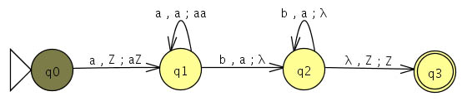
Figure 2.0
Action (read, pop; push)
q0 –q1 = a, Z;aZ mean “a” Symbol is a input(read) , Z is the default Symbol in stack.that meant stack is empty , aZ mean a Symbol push into stack.itsthe first Symbol in stack.
q1-q1= a, a; aa means “a” Symbol read then “a” pop from stack and push “aa” in to stack ,aa mean there can be two a’s or more than two a’s.
q1-q2= b, a; λ means b Symbol read then ”a” should pop from stack. λ push into stack. That mean nothing push into stack
λ,Z;Z mean accept the string and empty the stack. when accept sring it should be empty stack finaly.

Chapter 2
Proof that figure 2.0 accept string a²b^{2.}
If we consider a²b² as an example ,let’s see how its accepted by this pushdown automata(figure 2.0).
Instrution stack tape
Start Z aabb
Read Z abb
Push a a abb
Read a bb
Push a aa bb
Read aa b
Pop a b
Read a λ
Pop λ λ
Accept λ λ

After read all symbols if there are not any symbols in stack that’s mean its accepted .here when read a firs time it should remove from tape .then push a into stack. When read “b” it should pop “a” from stack. That’s why reducing a’s from stack when read b according to this automata.

Chapter 3
Design

3.1 Solve the problem using pushdown automata
Let assume “s ” as Symbol of snatch weightlifting system. “c” as Symbol of clean and jerk weightlifting system.
Name | 1st  snatch | 2nd  snatch | 3rd  snatch | Best  snatch | 1st  C & jerk | 2nd  C & jerk | 3rd  C & jerk | Best  C & jerk | Eligible | Total
A | 50  s | 55  s | 60  - |  | 90  C | 100  - | 100  c |  | √ | 155
B | 60  s | 70  s | 80  s |  | 100  - | 100  - | 100  - |  | -
C | 50  - | 80  - | 80  - |  | - | - | - |  | -
D | 50  s | 60  - | 80  - |  | 100  C | 110  - | 110  - |  | √ | 150

Table 1 : example of weightlifting result sheet after tournament

A – he has lifted two snatch and tow jerk ,then he is eligible for final list. because at least one snatch and one c & jerk he lifted. A is the winner.
B- although he lifted 3 snatch he couldn’t lift any c & jerk. so he is not eligible for final list.
C- He couldn’t lift any snatch so he can not lift even c & jerk he is rejected from snatch.
D -he is eligible for final list.

Chapter 3

3.1.1 Solution NPDA( pushdown Automata design )

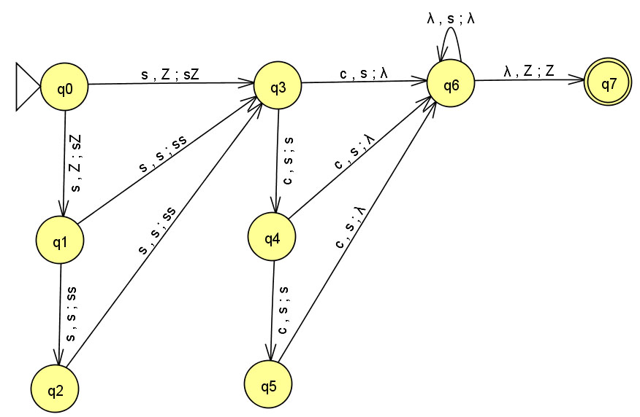
Figure 3.1
S - passed Snatch lift
c- passed clean and jerk lift
These are the strings who eligible for final list.

- Sc
- Scc
- Sccc
- Ssc
- Sscc
- Ssccc
- Sssc
- Ssscc
- ssssccc

Only above string will be accepted by this pushdown Automata.

Chapter 3
Example 3.1.1.1
Let assume there is a lifter who lifted two snatch and 3 clean and jerk. Then his String tape should be ssccc . Let’s check whether does accept that string in this push down automata.
Instrution stack tape
Start Z ssccc
Read Z sccc
Push s s sccc
Read s ccc
Push s ss ccc
Read ss cc
Pop, push s ss cc
Read ss c
pop s c
Read s λ
pop λ λ
accept λ λ
Therefore lifter who has ssccc string is accepted .then his total will be calculated.

Chapter 3

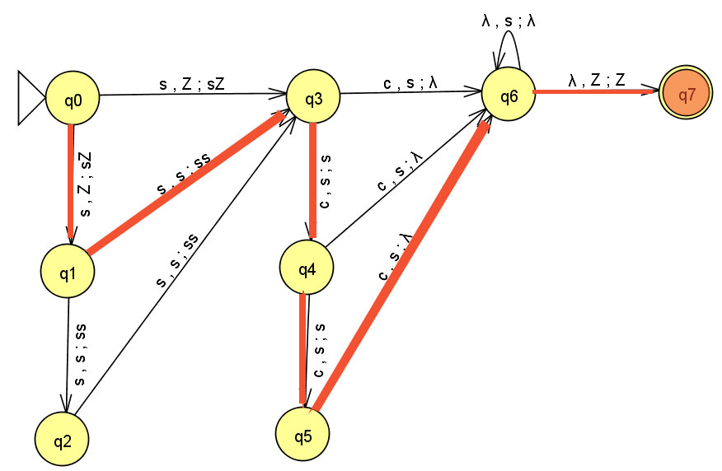

Figure 3.2 : Solution for example 3.1
In this example that weightlifter is selected to final list. After that we can define methods to calculate his best Total using best Snatch and Best clean and jerk. We can use sorting algorithm(Linear algorithm) to get best Lifts and calculate best total. As an example using java code. After get all relevant lifters Best Total then again push it into sorting algorithm then we can get the winner of that weight class. In here with out pushdown automata it will give us wrong information. Example If all snatches lifted lifter might not lift any clean n jerk. But Total will be calculated. But he should be rejected. That’s how pushdown automata use full for this task. Then final result will be come Automatically after put in String of the lifters.
Total = best snatch + best clean and jerk;
Winner = best Total.

Chapter 3
Sorting algorithm example
Int max_snatch;
Int weight[] = {50, 80,85}
max_Snatch=weight[0];
For(int i=1; i<3; i++){
If(max_Snatch <weight[i])
max_Snatch= weight[i];
} }

Example 3.1.1.2 Rejected weightlifter
If a weightlifter lift all 3 snatches but no any clean and jerk then he must be rejected . Let’s check whether he will be rejected .
String = sss
Instrution stack tape
Start Z sss
Read Z ss
Push s s ss
Read s s
Push s ss s
Read ss λ
Push s sss λ
Read sss λ
Not accepted. Because when tape is λ But there are symbol in stack. If stack is not empty at finally then it’s not accepted. So that weightlifter will be rejected.

Chapter 4
Discussion

4.1 How did I learn to create push down automata
I was searching many e book and internet links to lean pda. First of all I referred our recommend book [4] and I got an idea about what is pushdown automata. Then I search many link in internet which relate to pda. Then I found a link [8] and using that link I leant how to create a push down automata. Then I was thinking a problem . as my knowledge I decided to create a push down automata for my sport’s problem. That is weightlifting. I’m a national level weightlifter and I used to participate many tournaments and world level tournament. So I thought its better to make a solution for reject non eligible lifters in a tournaments. Then I created the design and set it to jflap software and I created he pda as a solution for my problem .while designing it I learnt more about pushdown automata using internet.

4.2 Other way of representing push down automata

Here we can draw push down automata design using start, read, pop, push & accept symbols. When we jump to another state it can represent using “(t)” . This design describe well what is pushing into stach and what is poping from stack. As an example if “a” put after push symbol that means a” push into stack. “According to Automata theory modem application book [4],[7] we can design above I mentioned pushdown automata(figure 3.2) as follow. Here gives result same as above way(see example 3.1.1.1 result table).
Example of symbols
Start t

Starting place
a
read
Read symbol “a”

pop
Push
a push “a” into stack a pop “a” from stack

(t) go to next state

Chapter 4
Start t
(t)
read
S(t)
read
read
Push
S(t)
Push
s
read
Push
pop
S(t)
Push
s
λ
s
pop
read
s
C(t)
s

C(t)
λ
Push
accept
s
C(t)
C(t)
s
C(t)

read

Figure 4.2.1 Push down automata for example 3.1.1.1

Appendix
4.3 Reference
- http://en.wikipedia.org/wiki/Snatch_(weightlifting)
- http://en.wikipedia.org/wiki/Clean_and_jerk
- http://www.iwf.net/
- Automata theory with modern Application book chapter 4.3 – james A.Anderson
- http://people.hsc.edu/faculty-staff/robbk/Coms461/Lectures%202008/Lecture%2018%20-%20Pushdown%20Automata%20-%20Examples.pdf
- http://goose.ycp.edu/~dhovemey/fall2008/cs340/notes/lecture5.html
- http://www.asethome.org/pda/PDA_htm.html?
- http://www.cs.duke.edu/csed/jflap/tutorial/pda/construct/index.html

